A stochastic, molecular model of non-small cell lung cancer fate decisions captures complex single-cell behavior in response to EGFR inhibition and substrate stiffness modulation showing changes in population dynamics and G1-period quantization

A stochastic model of cancer fate decisions reveals network topology required (sufficient) for extended G1-phase (quiescence)

A molecular model of cell fate decision captures stiffness dependent resistance in non-small cell lung cancer

A molecular model of cell fate decision captures single-cell and population-level to EGFR inhibition (stiffness dependence)

Substrate stiffness and signaling network noise contribute to EGFR therapy resistance (response?) in non-small cell lung cancer
Abstract
Focus on impact of microenvironment and signaling noise
Model shows signaling noise is sufficient to produce heterogeneous cell fate response, discussion question: if noise is sufficient what is the, increased noise increased plasticity?
One feature making NSCLC particularly difficult to treat is the heterogeneous single-cell fate response to targeted therapy. Understanding the causes of heterogeneity is important for developing functional treatments. Past work has focused on examining genetic heterogeneity across tumor cells that result in distinct subpopulations with unique drug-response profiles. Here, we supplement a growing body of work demonstrating the importance of cell microenvironment to treatment response. We next develop a mechanistic, molecular model to, first, recapitulate our population-level experimental results and, then, show that the signaling network is capable of producing slowly cycling cells concurrently with quickly dividing cells as an additional source of multi-fate response.
Targeted therapy of epidermal growth factor receptor has been a successful initial treatment for patients with non-small cell lung cancer. The disease, however, will generally progress as the tumors become resistant. One cause of resistance is linked to heterogeneity of cell fates in response to drug treatment. Underlying fate decision, and ultimately population response, is the complex signaling network of the cell. To understand the dynamics of a drug response, it is necessary to determine how external stimuli are integrated into a fate and how perturbations in the signaling network alter the decision process. In this study, we find that extracellular matrix (ECM) stiffness modulates proliferation behavior and the distribution of cell fates. Using these results, we have built a stochastic model capable of accurately predicting population dynamics – validated by in vitro evaluation of patient-derived lines. The model, once properly trained to data, could be a useful tool for quantitative prediction of drug response.

Outline:
- Experimental: Increased substrate stiffness results in increased mitotic rate, decreased apoptosis rate, and decreased quiescence rate in lung cancer cells. Substrate stiffness is an important factor in cell fate decision. (Fractional proliferation results)
- Experimental: Increased substrate stiffness decreases time spent in G1 (with a subset of cells spending approximately double the mean time in G1, part of the reason for implementing a molecular model to capture complex response). (IMT distributions)
- Experimental: Increased stiffness results in increased AKT signaling, increased FAK, and no change in ERK signaling. Erlotinib treatment results in decreased AKT, decreased ERK, and no change in FAK. Question: how are the differences in signaling manifested into fate responses and ultimately population dynamics? (Western blots)
- Need a molecular model capable of integrating molecular signaling level into multiple cell fate responses
- Model captures experimental population dynamics (similar mitotic, apoptotic, and quiescent rates) (Jeremie’s work, model validation)
- Molecular components match known experimental results (CDK 4/6 (Meyer), CDK2(Meyer and Spencer), Rb(Spencer), p21(Spencer), E2F). Model matches experimental results naively, the model was not fit using this experimental data
- Stochastic simulation is capable of producing varied fate response
- FAK modulates Rb-E2F signaling threshold, the amount of input signal (through AKT and ERK) necessary to pass the G1/S transition is lowered by increasing FAK
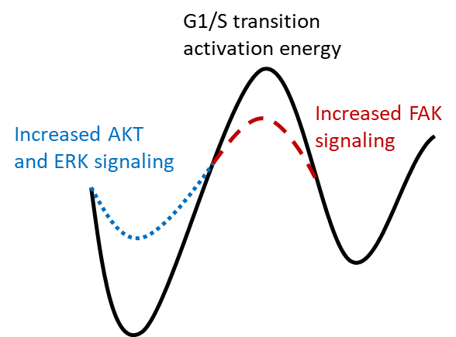
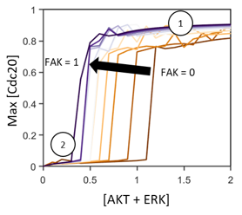
- How does change in stiffness change the restriction point? What are the components within the network that change as stiffness is varied? Is it better to inhibit Cdk4/6 or Cdk2 through p21 pathways?
- System bifurcation is sufficient to cause lengthened G1 time at intermediate signaling strength. System behavior is driven by components of the Rb-E2F switch. Increased Rb and p21, and decreased E2F, pRb, and CycE 5 hours before mitosis are markers of increased division time in the subsequent cell cycles. Is one particular protein sufficient to drive increased G1 time?
- AKT and ERK are directly tied to apoptotic pathway vs. FAK in Rb-E2F
Discussion points:
(microenvironment remodeling in tumor progression, comorbidities, and metastases)

Work this week:
Organize data for upload and data access (with code for figures and analysis) on github
- All experimental IMTs, Western data, background modeling work

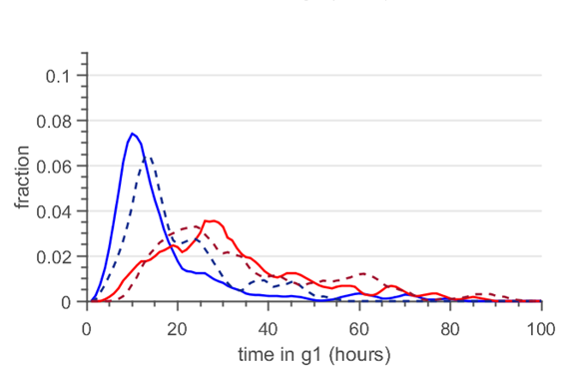
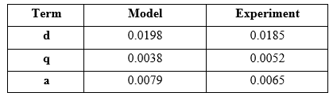
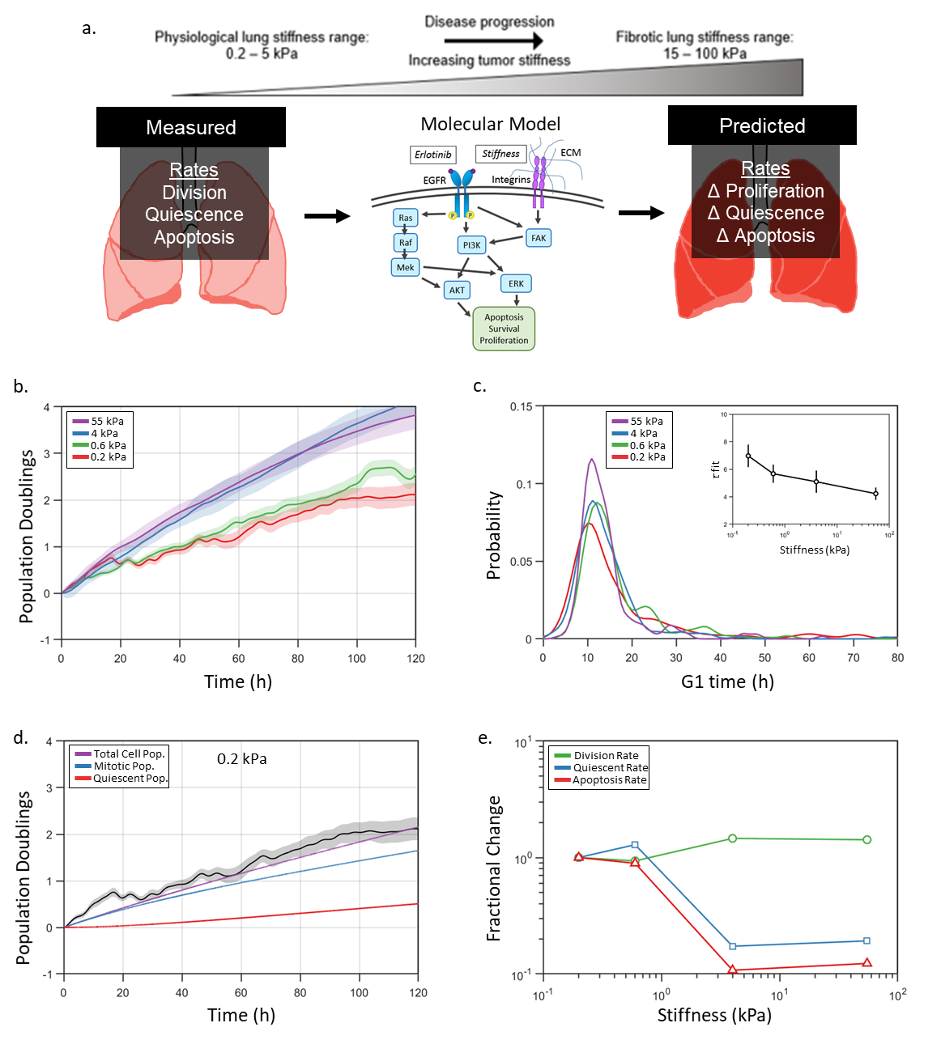
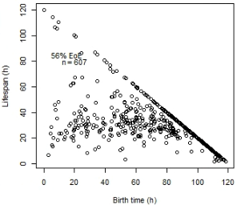
- Examine fits:
1.52e-09
7.48e-28

- Examine Rb-E2F components

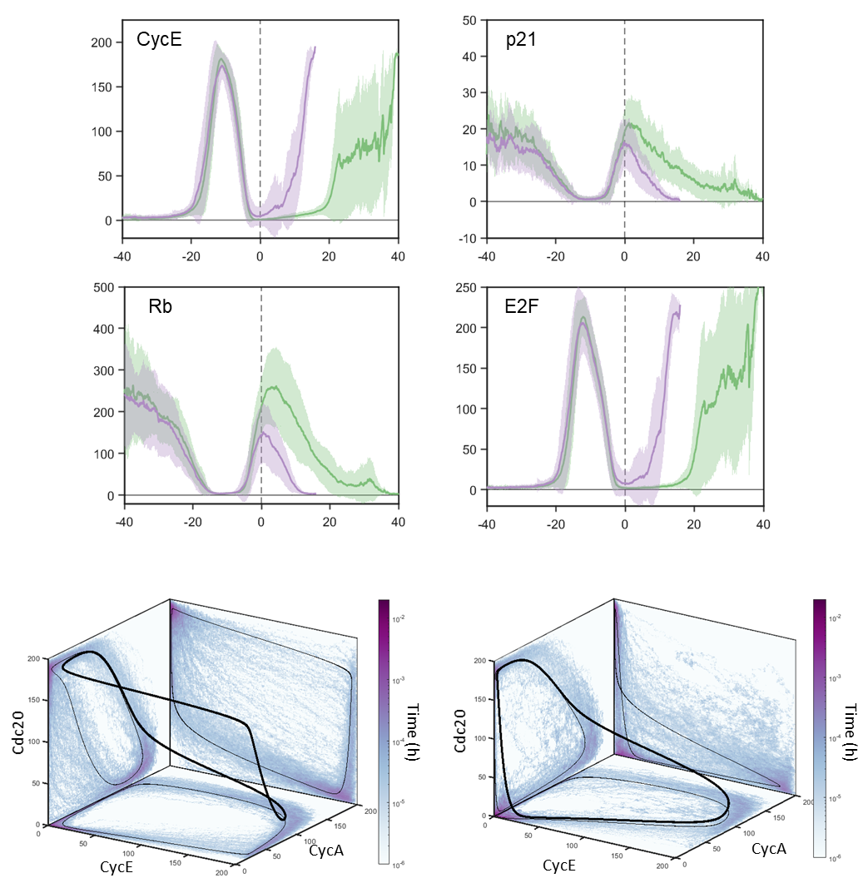
Sections:
Abstract
Introduction
Methods
- A molecular model linking apoptosis, cell cycle, and the Rb-E2F switch
Results
- Experimental: Increased stiffness results in increased mitotic rate, decreased apoptosis rate, and decreased quiescence rate in lung cancer cells.

- Experimental: Increased stiffness results in increased AKT signaling, increased FAK, and no change in ERK signaling. Why? Signaling dynamics
- Molecular model of mitosis and apoptosis including AKT, ERK, and FAK recapitulates experimental IMT distributions and fractional proliferation rates (include in model building, modifications to existing models, parameter fitting)
- Computational model predicts the effects of stiffness on proliferation rate for erlotinib treated lung cancer cells
- Cell cycle length is not the result of one specific driver (e.g. CycE) using correlation of IMT and single protein signaling level at mitosis
  - Increased Rb, decreased E2F, decreased CycE signaling 5 hours before mitosis predicts increased G1 time in daughter cells
  - Knocking out p21 results in decreased IMT, specifically G1 time, with no variation in G2-S-M.

Introduction

Tumor recurrence remains a major hurdle
How cells interpret their chemical and mechanical environments to make fate decisions remains an open question at the interface of multiple disciplines. Cancer, generally speaking, is a misappropriation of the cellular machinery responsible for those decisions. Targeted therapy of epidermal growth factor receptor (EGFR) has been a successful initial treatment for patients with NSCLC. The disease, however, will frequently progress as the tumors become resistant. One cause of resistance is linked to heterogeneity of cell fates in response to drug treatment. Underlying fate decision, and the resulting population response, is the complex signaling network of the cell. To understand the dynamics of a drug response, it is necessary to determine how an external stimulus is integrated into fate determination and how perturbations in the signaling network alter the decision process.

Previous work has focused on identifying key mutational drivers and quantifying the dynamic changes to cell fate that occur upon treatment, describing the flux between populations of dividing, dying, and quiescent cells⁵. These changes directly translate into the variation of overall population number and intermitotic time (IMT). Ultimately, cellular regulation of the mitotic and apoptotic pathways dictates overall disease response and subsequently, patient outcome. As the signaling networks of the cell are vast and complex, computational modeling of the cellular circuitry has emerged as a valuable tool offering insight into the behavior of these networks and suggesting novel mechanisms of system control.

In this study, we relate a molecular-based stochastic model of the cell cycle and apoptosis to experimentally measured population-level cell behavior. We show that a simple, interconnected model is capable of accurately producing cell population behavior and complex IMT distributions observed in vitro. Our model is able to connect the effects of variations at the single cell molecular-level to characteristics of the cell population as a whole.

The basis of our model is centered on the system of four cyclin-dependent kinases (Cdks), that control the ordered progression through the phases of the cell cycle: Gap 1 (G1), DNA synthesis (S), Gap 2 (G2), and mitosis (M). A fifth phase, Gap 0 (G0), is used to describe cells that have left the cell cycle and are not actively dividing, or quiescent cells. Recent work has identified the G0 population as an important collection of cells in the development of cancer treatment resistance. We extend a skeleton model of the mammalian cell cycle, a reduced version of a much larger model, both proposed by Goldbeter et al. Our model is a simplification of an expansive ‘bottom-up’ model that exchanges many biochemical intricacies for emphasis on the minimum network architecture necessary for complex oscillatory behavior. Identically to the full model, our reduced version is driven by the chronological activation of the cyclin group of proteins and their associated kinases. Each phase of the cell cycle corresponds to the activation of a specific member of this family: cyclin D/Cdk4-6 induction marks the progression of G1, increase in cyclin E/Cdk2 identifies the G1/S transition, cyclin A/Cdk2 activity indicates S and G2 phase, and cyclin B/Cdk1 precipitates M phase.

Additional features of our model include the G1/S restriction point in the form of the Rb-E2F bistable switch. The restriction point in this form provides a sharp threshold for cell cycle activation that is otherwise absent in the reduced model. We also incorporate the proteins Skp2, Cdh1, and p21/p27 to allow for substrate stiffness influence on the cell cycle through the activation of the FAK signaling axis. To integrate cell death, we include the initiator module of an apoptosis model proposed by Tyson et al. The initiator module functions as a switch describing BAX activation. Upon sufficient stress signal, pro-apoptotic BH3 protein level increases. Initially, BCL2 sequesters BH3 by binding to it. However, if the stress signal is maintained, BH3 will continue to accumulate, activating BAX. The activated, mitochondrial-bound form, BAXm, promotes the release of BH3 from BCL2. Once this module is active, irreversible pores are formed within the mitochondrial membrane, augmenting permeability to cytochrome c. A key component of our model is bistability in both apoptosis and mitosis, allowing for signal threshold activation of both elements.

We substantiate our model by comparing its behavior to experimentally measured IMTs and total cell number for oncogene-addicted NSCLC cells. The approach allows us to adjust input strength to the mitotic and apoptotic modules in the form of EGFR signaling, substrate stiffness, and cMet expression and to quantify both single cell and population level effects of these perturbations. EGFR signaling indicates the presence of drug. Substrate stiffness is relevant in the case of late-stage cancers that metastasize to softer or harder tissues. NSCLC is often not diagnosed until advanced stages and its most common metastatic site is bone, a tissue 500 times stiffer than lung (cite). Variation in cMet signal allows us to model the response of NSCLC subpopulations that are resistant to current/initial/gold standard/available drug therapeutics. We find that decreased substrate stiffness increases sensitivity to EGFR-targeted therapy in drug-resistant sublines. While drug treatment and stiffness can have the same overall effect on total cell number, division behavior is markedly different between the two environments. Additionally, we show that IMT distributions are bimodal, with a small fraction of cells dwelling in G1/G0 for approximately double the period. Our model is sufficient to capture these phenomena.

We demonstrate the advantages of using a simplified model that still retains the complex behavior found in the comprehensive version. For example, if we deconstruct the model into two oscillating circuits, we lose the period doubling feature observed in vitro. Since simplifying the model would lose this key biological characteristic, we know both loops are required for an accurate model. Our model links the period doubling to low cyclin E/Cdk2 activity at mitotic exit, proposing a novel mechanism, which demonstrates its usefulness. Our model retains the necessary structure to make insightful predictions while being computationally efficient.

As the tumor cells proliferate, they remodel their environment, optimizing it for growth. The extracellular matrix (ECM) is typically composed of collagens I, III, IV, and V (mostly collagen I), fibronectin, laminin, elastin, and osteonectin arranged in specific orientations to provide structure, a network that guides migration, and present ligands that stimulate signaling. In the case of NSCLC, excess osteonectin can be synthesized to promote invasion and migration. Tumor migration is also supported by increased and organized collagen deposition. Conversely, a matrix composition with higher elastin content prevents cancer cell migration. The excessive growth of fibrotic tissue around the tumor, or desmoplasia, is characterized by thick bundles of collagen fibers and can inhibit tumor migration. This increased ECM density has also been reported to prevent T cells from infiltrating the tumor microenvironment [11], [16].

Results

Soft substrate decreases overall cell number similar to erlotinib treatment
In order to examine the effect of substrate stiffness and EGFR inhibition (with erlotinib) on cell fate decision, we used the EGFR-mutated NSCLC PC9 cell line. We investigated two separate discrete sublines from the parental PC9 population, hereafter referred to as DS8 and DS9, which have been previously characterized as showing a resistant and sensitive phenotype to EGFR inhibition, respectively. Cells were grown on polyacrylamide substrate of varying stiffness, modulated from 0.6 kPa to 55 kPa, coated with fibronectin. For tracking and analysis purposes, cells were labeled with H2B-mRFP and Geminin-mAG. The first allows for continual tracking of individual cells for the course of the experiment while the latter marks the transition from G1 to S phase, remaining expressed until the cell divides. Cells were imaged every 20 minutes over a period of five days.

We followed the change in overall cell population using the methodology developed by Quaranta et al. called the drug-induced proliferation (DIP) rate. The DIP rate is the linear fit of cell population doubling as a function of time after the point of linear response. Using the DIP rate as a growth metric over other fits such as logistic growth allows us to compare a single fit quantity across cell populations that are expanding or declining. On the stiffest substrate (55 kPa), the two sublines behave as previously described with no significant difference between subline DIP rates (Fig1). Upon erlotinib treatment, the underlying sensitivity heterogeneity is made apparent with DS8 showing no significant change in DIP rate and DS9 showing a distinct negative rate (Fig1).

We then investigated the effects of substrate stiffness on DIP rate for both untreated and erlotinib-b treated cells.
As the substrate becomes softer, cells show a marked decrease in growth rate under DMSO conditions, still, with little difference between sublines. All DIP rates, regardless of stiffness, are positive with no drug treatment. Here we point out one limitation of the DIP rate: as the DIP rate expresses the linear fit of the population change over a given window, it does not fully capture all of the dynamics of a cell population. Namely, the initial response and behavior of the cells. On our softest substrate, the DIP rate is significantly different between sublines. However, when using a logistic fit to describe cell number, we find similar behavior between the two (Supp. Fig 1).

We know from previous work (Quaranta citations) that DS8 and DS9 respond disparately to EGFR inhibition. In light of our results showing a change in DIP rate with substrate stiffness, we investigated if and how substrate stiffness affects sensitivity to EGFR inhibition. We find that both cell lines behave similarly to previous results on our stiffest substrates. Specifically, DS8 continues to proliferate in the presence of EGFR inhibitor, marked by a positive DIP rate, while DS9 shows a linear, negative DIP rate response after erlotinib treatment. At the intermediate stiffness of 4 kPa, the resistant cell line shows a decreased DIP rate and, intriguingly, at our softest substrate of 0.2 kPa, the resistant cell line exhibits a negative DIP rate. Of note, the erlotinib-treated DS8 grown on 4 kPa substrate responds with the same curve and DIP rate as the non-treated DS8 grown on 0.2 kPa substrate (Fig 1 and Supp Fig 1). DS9 shows sensitivity across all substrates with a substantial negative DIP rate. There is a small decrease in DIP rate on the 0.2 kPa substrate compared to the 55 kPa substrate. Additionally, as substrate stiffness increases, the DS9 subline shows a higher cell count before the action of drug treatment is evident (Supp Fig 1).

Erlotinib treatment lengthens G1 time in a substrate stiffness-dependent manner
The decreased DIP rate observed in cells grown on soft substrates and in the presence of EGFR inhibitor led us to investigate the origin of the decreasing cell number. A change in DIP rate is produced by a change in fraction of actively dividing, dying, or quiescent cell populations. We investigated the cause of this change in our cells by modulating the stiffness of the substrate in addition to treating with erlotinib. To track variations in cell cycle progression timing we used a fluorescent marker for G1/S transition, Geminin-mAG. The marker is expressed at the onset of S-phase until the cell completes mitosis. We followed both the time that Geminin was not expressed, labeled G1, and the time that Geminin was expressed, S/G2/M, for individual cells across experiments (Supp. Fig. #).

We fit a log-normal distribution to cell cycle events to allow comparison between experiments, noting however, that the fit does not capture all the features of our experimental distributions. Please see the supplemental information for fitting errors. Additionally, we find that upon drug treatment, there is a delay until drug action. For this reason, we capture cell cycle dynamics data for times greater than 24 hours. We first observe that changing substrate stiffness has little apparent effect on G1 length as exhibited by slight change in mean G1 time. Comparing erlotinib-treated cells to their counterparts grown on the equivalent stiffness substrate, we see an increase in G1 time. For erlotinib-treated cells, average G1 time increases approximately linearly as a function of the log stiffness. Additionally, we find that the standard deviation increases for both treated and non-treated cells with decreasing substrate stiffness, and that treated cells have a greater standard deviation than their non-treated equivalents. Indeed, the slight change in mean G1 time for untreated cells is the result of increasing deviation of the distribution.

Both substrate stiffness and erlotinib treatment increase S/G2/M times
Next, we compare the effects of modulating substrate stiffness and erlotinib treatment on S/G2/M timing. The first observation we note is that the shape of the distribution is more Gaussian than the G1 distribution. We observe little difference between a Gaussian and log-normal fit of the experimental data. As substrate stiffness is decreased, the time spent in S/G2/M increases from approximately 10.5 hours to 13 hours, indicating that the decreased DIP rate is primarily produced by this event. All erlotinib-treated cells have increased S/G2/M time in comparison to their untreated counterparts. There is an increased broadening of the distribution on soft substrate from untreated to treated cells that disappears on the 55 kPa substrate. Decreased DIP rate from erlotinib treatment is the result of a combination of increased death rate and extended time in both G1 and S/G2/M.

A subset of cells spends approximately double the mean time in G1
A major factor for the poor fits using either an exponentially-modified Gaussian or log-normal fit for the G1 distributions is the appearance of a secondary peak at approximately double the average G1 time. We have found a small subset of cells take approximately twice as long to complete the G1/S transition. A clear example of such an event is shown in supplemental video 1. Decreased stiffness and erlotinib treatment both increase the fraction in the second peak, with the greatest fraction occurring on the 0.2 kPa substrate with erlotinib treatment. Using a right-skewed fit as a description of the distribution both overestimates intermediate G1 times and underestimates extended G1 times. This is the first characterization that we are aware of examining the G1 delay as a second peak instead of a lengthened tail.

Coarse-grained candidate model
We then asked if a simplified molecular model of the cell cycle was capable of capturing the period doubling behavior we observed. Would decreased signaling strength result in decreased DIP rate? We assembled our minimal model seeking to strike a balance between a biologically-relevant, complex description containing a multitude of parameters and a simplified description containing fewer parameters but missing key behaviors. Our model is based upon the extended skeleton model, a simplified version of a detailed model of Cdk oscillations, both proposed by Goldbeter et al (cite). The skeleton model consists of four cyclin/Cdk complexes that stimulate and mark progression through the cell cycle while keeping the qualitative features of the larger model.

As inputs for our model, we consider the surface receptors EGFR, cMet, and integrins, and how changes in signaling strength along these pathways result in changes in cell fate decision. Instead of fully modeling the transduction pathway from receptor to cell cycle, we measure AKT and ERK activation levels as an assessment of signaling strength. All three of these receptors signal through the AKT and ERK axes. Increased AKT and ERK signaling leads to the increased expression of the pro-proliferative transcription factor Myc and activation of cyclin D/Cdk 4-6 complex (cite). We have added to our simplified model the pRb-E2F switch that composes the G1 checkpoint. The decision to enter the cell cycle is regulated by pRb and E2F levels. E2F is upregulated by Myc, resulting in the promotion of cell cycle progression through the activation of cyclin E/Cdk2 and cyclin A/Cdk2 complexes. Concurrently, activation of the cyclin D/Cdk 4-6 complex results in the inhibition of pRb, an inhibitor of E2F and, consequently, the cell cycle. Once a signaling threshold is reached, the cell cycle continues with the activation of the cyclin E/Cdk 2 complex, marking progression into S-phase. Cyclin E/Cdk 2, in turn, strengthens E2F signaling through the inhibition of pRb. Increased cyclin A/Cdk 2 activity leads to the inactivation of cyclin E/Cdk 2 complex and E2F, ensuring proper timing through the cell cycle. In our model, peak cyclin A/Cdk 2 activity corresponds to the transition from S to G2. Cyclin A/Cdk 2, in turn, activates the cyclin B/Cdk1 complex, inducing the cell into M phase. As the final step, cyclin B/Cdk 1 activates Cdc20, which inhibits both cyclin A/Cdk2 and cyclin B/Cdk1. Additionally, we have included the Cdk inhibitor p21-p27, which itself is inhibited by Skp2. Including both of these proteins allows us to include another mechanism of integration connecting substrate stiffness through integrin and FAK signaling to the cell cycle.

After establishing this candidate model, we examined how varying levels of EGFR activation, cMet expression, and substrate stiffness affect AKT and ERK activation levels and overall cell population dynamics.

Varying stiffness primarily affects AKT signaling in comparison to ERK
The single cell experiments indicate cellular sensitivity to substrate stiffness. To connect changes in overall cell number response we quantify key regulators within the protein signaling network.

Met levels

EGFR inhibition through erlotinib treatment strongly affects ERK signaling over AKT

RTK and FAK signaling set AKT and ERK response levels.

The DIP rate is not a discrete state description of cellular response, meaning two groups of cells may have the same DIP rates but have different underlying behaviors. For example

Soft substrate leads to decreased DMSO growth rate and increased erlotinib sensitivity
Substrate stiffness primarily impacts S-M time
Erlotinib treatment strongly affects G1 time
Appearance of a secondary G1 doubling peak (consideration of G1, S-M distribution fitting)
Stiffness affects AKT signaling
Erlotinib drastically decreases ERK and moderately affects AKT

Model reveals timing
The underlying assumptions of the model are important to interpreting the results. Using the EMG as a fit is inspired by the transition probability model of the cell cycle.⁶ An exponentially modified Gaussian fit assumes a probabilistic

The next question we asked is how does the underlying network behavior manifest into a population response. That is, how do the numbers of cells within the changing

Experiment: DIP rate – to PC9 subline is not a 1-1 mapping. DIP rate depends on the input of multiple environmental factors.
Presented a candidate model to take measurable inputs (stiffness / protein activity) and predict population growth and cell fate distributions (G0, S-M time)
Minimal model requires 3 inputs and 3 targets
Both experiments and model reveal intriguing shape to G1/G0 distributions -> containing 2nd peak

Current Hypothesis for 2nd peak: solutions with low model inputs have complicated oscillations and multiple limit cycles. Stochastic simulations kick the “cells” into different limit cycles.

Figure 1: Signaling Pathway Schematic
Figure 2: Population analysis
Figure 3: Cell cycle dynamics, cell cycle distributions

Figure 4: Western results
Figure 5: ODE model analysis
Figure 6: Stochastic model analysis/comparison

Discussion
Fate decision represents an important and common event in cellular behavior. Understanding how that choice is made has important implications for our understanding of cancer progression. Here, we show that it is possible to use a simplified, molecular model to accurately capture single cell behavior and population level dynamics. This model exists as an important middle ground between large, all-encompassing molecular models and simplified mathematical schemes [100][101]. The former can offer powerful insight if properly tuned, but with vast numbers of parameters to estimate, it is difficult to know if the optimal estimation has been achieved. The latter may coarse-grain the biological steps too much, losing important system behaviors. In fact, the level of detail to include in a model to achieve a particular phenomenon answers important questions regarding the signaling topology and overall architecture of the network. We considered these tradeoffs when designing our model, taking cues from the prior and ongoing work of Goldbeter and colleagues. His original work designing a full, descriptive model of the mammalian cell cycle and he subsequently simplified it down to the essential components to achieve phenomenologically similar oscillations. This offers important insight into the control scheme of the cell cycle. Additionally, it makes testing network connections within the model quicker. We use the same approach to begin asking what the necessary components are to reproduce experimentally quantified cellular behavior, intermitotic times, death rates, and drug-induced proliferation rates, given known signaling input. The problem is inherently multiscale in nature, starting with a description of molecular events and eventually describing the change in population.
The first step in the process, achieved over many years of biochemical study, was identifying the components of the cellular signaling system. After, and concurrent with, component identification, many studies have focused on describing how the elements interact. Our work picks up at this point, using the years of prior work to build a literature-based model. Our model combines the Goldbeter skeleton model that includes positive feedback leading to bistable transitions and combines it with the Rb-E2F bistable switch characterized by Yao et al. [48], [102]. Thereby, we include the necessary components and multiple feedback loops necessary for complex system behavior.
An important control mechanism of treatment response was substrate stiffness. We modeled stiffness input as FAK activity in our model. FAK both helps set AKT level, measured experimentally, and controls the level of p21 through Skp2 activation. p21 in turn binds to cyclin complexes, effectively removing them from the available pool to drive the cell cycle. Cyclin-dependent kinase inhibitors, such as p21, can effectively block the progression of the of the cell cycle by changing the dynamics of the Rb-E2F switch [103]. By including the mechanism of molecular bistable switches, we were able to construct a system that exists in three regimes: a high signal actively oscillating state, an intermediate signal quiescent steady state, and low signal apoptotic steady state.
We characterized the nature of the oscillations and inquired if a simple, molecular model can capture the intermitotic time distributions observed experimentally. The stochastic model accurately recapitulates the trends of our experimental results. Comparing the distributions of experimental G1 and S-G2-M to those of the model, we find the same right-skewed distribution for G1 and more Gaussian distribution for S-G2-M. The model captures the signal-dependent shift of G1, with mean time shifting rightward as signal decreases. Surprisingly, we find the same multimodal structure present in our model results as seen in our experiments.
The existence of such structures has been noted historically as ‘cell cycle quantization’ and been found across eukaryotic species [95], [104], [105]. Prior work has focused on describing these structures in yeast mutant cells (wee1- cdc25Δ) [94]. Our work builds upon these studies, demonstrating that if positive feedback loops that accelerate the G2/M transition are weak, then cells can revert back to G2, effectively adding a quantized amount of time to the cell cycle. Instead of extended G2-M mitotic time, we find a quantized G1 time that is dependent on signal strength. This leads to questions of the similarity between the circuits and how a change in signal strength leads to complex oscillations. We find the quantization is the result of the coupling of multiple oscillatory circuits within the cell cycle.
We further note that the slowly and quickly dividing states are transient within our model and a result of molecular noise, rather than a specific genetic expression level. We compare the molecular evolution profiles of the two groups and find interesting differences between the two. The first feature we point out is a consistently decreased level of Skp2 signaling in long cycling cells. When Skp2 is low, inhibition of p21 is also low, leading to a quicker cell cycle. Skp2 has been shown to be necessary for the degradation of cyclin-dependent kinase inhibitor (CKI) for proper cell cycle progression [106]. Our model further supports experimental findings by Meyer et al. showing the proliferation-quiescence decision is dependent on Cdk2 activity at mitotic exit [107]. We model cyclin E in complex with Cdk2 and observe increased activity of the complex at mitosis for quickly dividing cells. It is difficult to say our model is dependent on the activity of one protein at a specific point in time to cause a specific outcome. The entire state of the system, the molecular count, at a specific time is what dictates the evolution of our system. However, we can say, given a set of molecular counts, the likelihood of the model behaving a certain way.
As a means of further testing our model, we examine the effects of what would be the experimentally analogous process of p21 knockout. By setting the p21 synthesis to 0, we can compare model dynamics to our ‘wildtype’ experiment. We see that with p21 knockout, there is a large increase in quickly dividing cells. The change in intermitotic dynamics comes from a shortened time in G1, as opposed to S-G2-M. We find this surprising since p21 interacts with all cyclin complexes. The role of p21 in cell cycle progression can be further explored by changing its association and dissociation constant with the cyclin family. An interesting note is that the cyclin E/p21 complex is the only cyclin/p21 associated complex that shows a greater molecule count that correlates to quickly dividing cells.

The use of computer modeling is clearly necessary for understanding the dynamics and intricacies of cellular signaling pathways. Many groups have modeled cell signaling with varying emphases and levels of detail, begging the question: What is the appropriate amount of detail to include in a model? A successful approach has the ability to capture and interpret complex phenomena arising from network interactions while being as simple as possible. In this study, we utilize a molecular-based approach to understand cell fate decisions.

How does extended feedback affect signaling? Including RNA expression (introduction of noise) and post translational modification

Failure to incorporate stochastic gene expression into cell cycle submodel (Birtwistle). “Principally, cells would randomly commit to cell division in the absence of a mitogenic stimulus.”

The development of molecular tools, additional Fucci markers to examine the timing of other components of the cell cycle

How do oscillations in AKT and ERK activity levels affect fate decision? How does longer time interval feedback affect decision (e.g. expression and degradation)

The results do not preclude the possibility of separate signaling channels other than AKT and ERK. In fact,

Cell lineages

The perturbations we have challenged the cells with

The switches behaving independently would lead to log-normal distribution. “A log-normal process is the statistical realization of the multiplicative product of many independent random variables.” The processes of the cell cycle are coupled

A simple model of the cell cycle, including important feedback loops, is sufficient to capture complex cellular phenomena.

Methods

Cell Culture:
PC9 discrete sublines were obtained from the laboratory of Vito Quaranta (Vanderbilt University). They were derived as single cell clones from parental PC9 cell line, expanded in drug-free media, and fluorescently labeled with Geminin-mAG (Fucci system) and H2B-mRFP. Cells were cultured in CO₂ (5%), temperature (at 37°C), and humidity controlled incubators. Before use, the cells were confirmed to be negative for mycoplasma using MycoAlert PLUS kit (Lonza). Cells were cultured in RPMI 1640 media supplemented with 10% FBS (Atlanta Biologicals) and Antibiotic/Antimycotic mix (Gibco). During imaging, the media was substituted for OPTI-MEM media (Gibco), supplemented with 2% FBS, and Antibiotic/Antimycotic mix to reduce background auto-fluorescence. The growth rate was confirmed to be the same for these sublines in both types of media.

Polyacrylamide Substrate Gels:
2-D polyacrylamide gels are made according to the protocol of the Gardel laboratory⁷. Briefly, circular glass coverslips are activated with 3-aminopropyltrimethoxysilane (3-APTMS) and glutaraldehyde. The coverslips are immobilized on the bottom of a 6-well plate. Polyacrylamide solution of a chosen stiffness is allowed to polymerize between a hydrophobic coverslip and an activated coverslip. The hydrophobic coverslip is gently removed from the well using a razor blade edge. Sulfo-SANPAH is placed upon the gel and exposed to UV light, changing in color from red-orange to brown. UV-treated coverslips are quickly washed in ddH₂O and coated with 0.1 mg/ml collagen. Collagen is allowed to bind for 1-2 hours at room temperature or overnight at 4°C. Gels are then washed extensively with PBS (pH 7.4) under sterile conditions and sterilized under a germicidal lamp in a tissue culture hood for 30 minutes.

Time Lapsed Microscopy:
Images are taken on Axio Observer Z1 spinning disk confocal microscope (Zeiss, serial #3834004261). During imaging, the cells are maintained in incubation conditions of 5% CO2, 37°C temperature, and constant humidity. Images were acquired with 20X objective at the following laser settings: 561λ at 12% laser power and 4ms exposure, 488λ at 1% laser power and 2ms exposure. The imaging consisted of a 12x12 mosaic with 20 μm overlap, each frame was 400 μm x 400 μm. Images were acquired every 20 minutes for a minimum of five days.

Western Blots:
Cells were lysed in RIPA buffer (Sigma) supplemented with protease inhibitor cocktail (Roche) and phosphatase inhibitor cocktail (Roche). The difficulty in removing cells from the PA gels lead to lysing them straight on the gel. Sample lysates were boiled with Laemmli sample buffer and loaded in a 4-20% gradient gel (Bio-Rad) for electrophoresis. Protein was transferred to polyvinylidene difluoride membranes and then blocked with blocking buffer (LI-COR) and incubated with primary antibodies overnight at 4°C. After 3× washing with TBS, secondary antibodies were applied for 1 hour and then washed with TBST (0.05% Tween 20) before imaging. Blots were scanned using the Odyssey imager (LI-COR). Densitometry was performed using ImageJ software.
All antibodies are from Cell Signaling Technology and are as follows: phospho-FAK(Tyr397) #8556, FAK #13009, phospho-ERK and ERK (Thr202/Tyr204) antibody duet #8201, phospho-EGFR and EGFR (Tyr1068) antibody duet #11862, phospho-AKT and AKT (Ser473) antibody duet #8200.
Model Algorithm, processor used to solve

Quiescence-Growth Model:
The proliferation kinetics model describes the rate at which cells change the overall population given the rates of cells proliferating, dying, and entering quiescence. The model is represented by a pair of ODEs with x characterizing the number of dividing cells, y the number of quiescent cells, and x+y the total cell number. Rate constants for the equations are as follows: d, cell division rate, q, quiescent rate, and a, the death rate.
 | $$\frac{dx}{dt}=\left(d-q-a\right)x$$ | (4.4)
 | $$\frac{dy}{dt}=qx-ay$$ | (4.5)
The analytical solution for the equations is:
 | $$x(t;x_{0},d,q,a)=x_{0}e^{\left(d-q-a\right)t}$$ | (4.6)
 | $$y(t;x_{0},y_{0},d,q,a)=\left(y_{0}+x_{0}\frac{q}{d-q}\left(e^{\left(d-q\right)t}-1\right)\right)e^{-at}$$ | (4.7)
If the division rate d is greater than the sum of the quiescence rate q and apoptotic rate a, then the system will approach exponential growth. Including a quiescent population allows for nonlinear proliferation curve.

Main Figures
Figure 1:

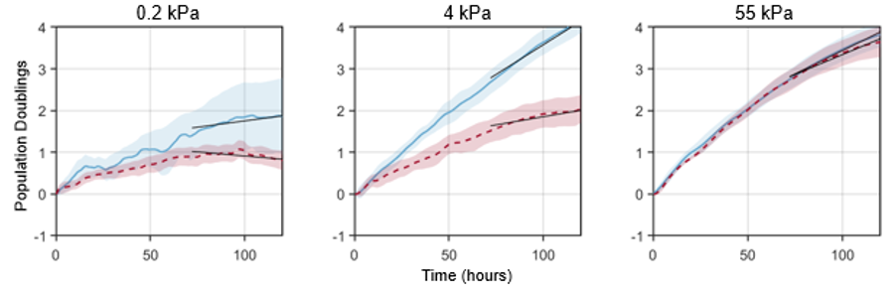

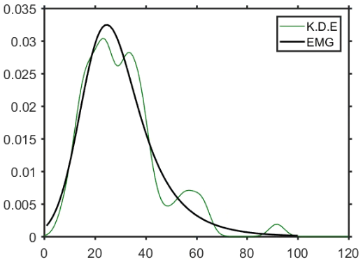
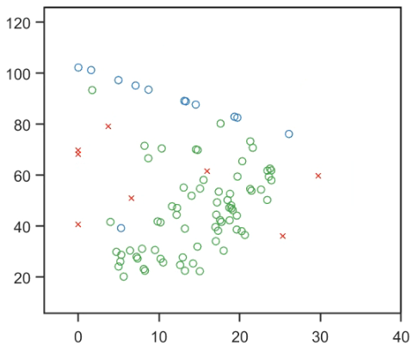
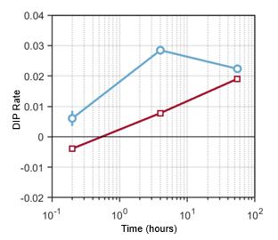

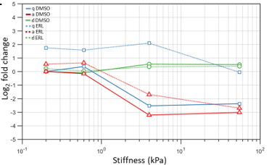

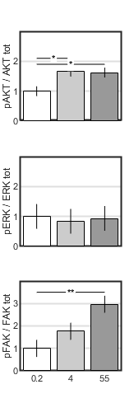
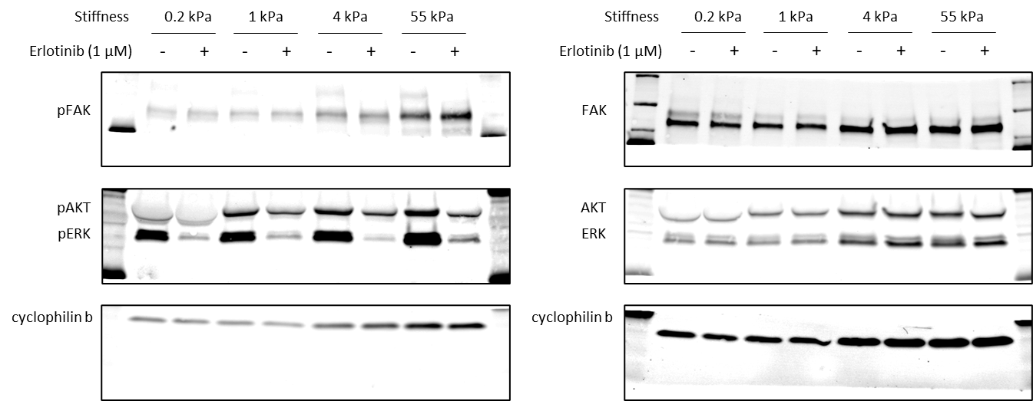
b.
a.
Stiffness (kPa)

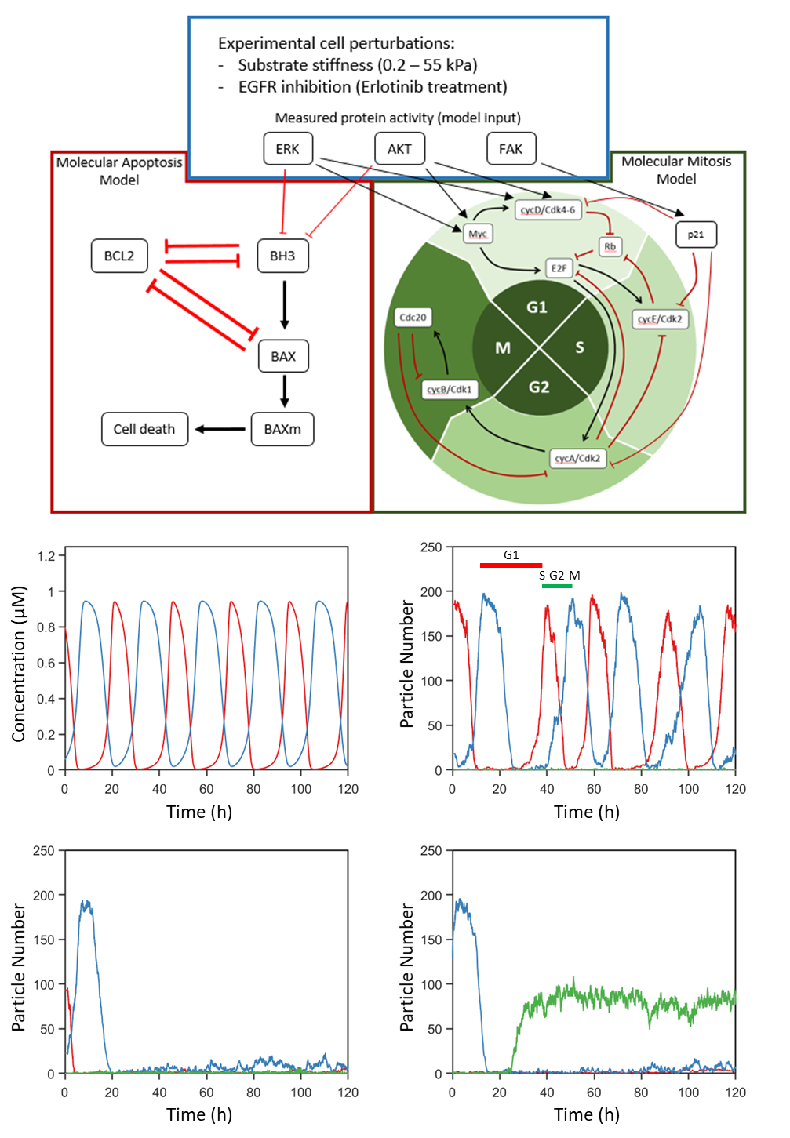
e.
d.
c.
b.
a.

Figure 4. Jeremie’s parameters with experimental comparison
a.

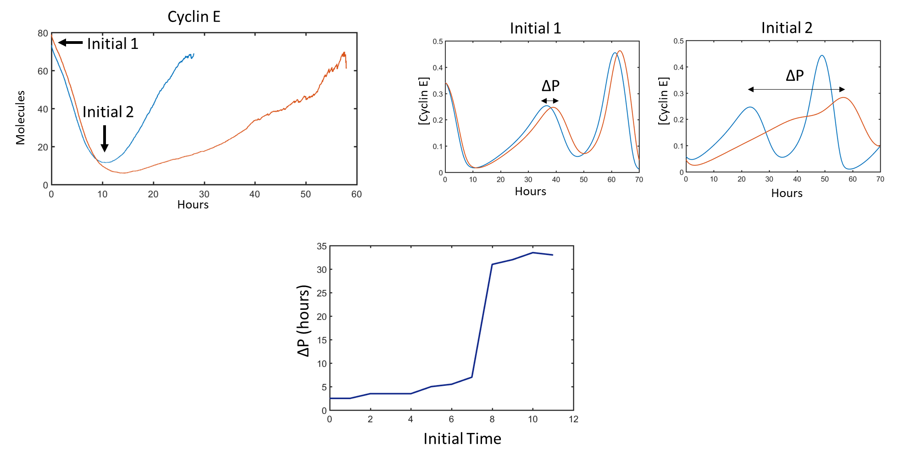
Supp. Fig. Timing of restriction point

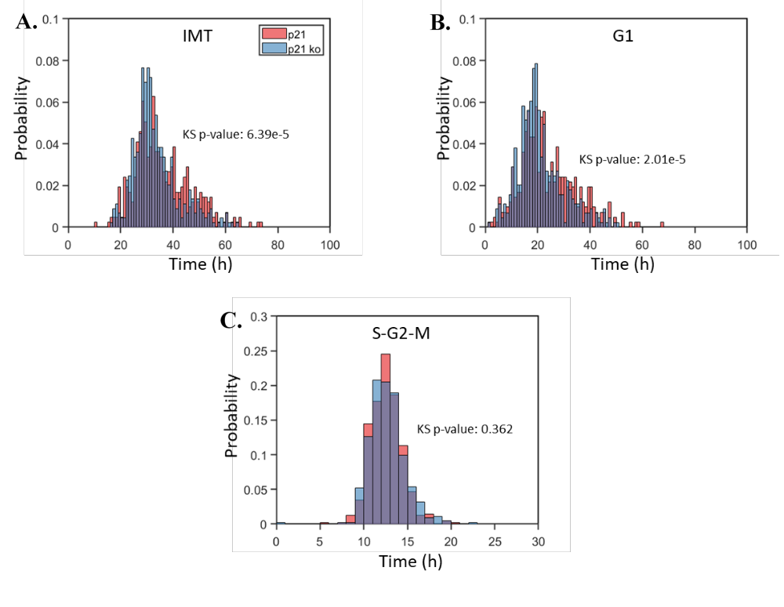

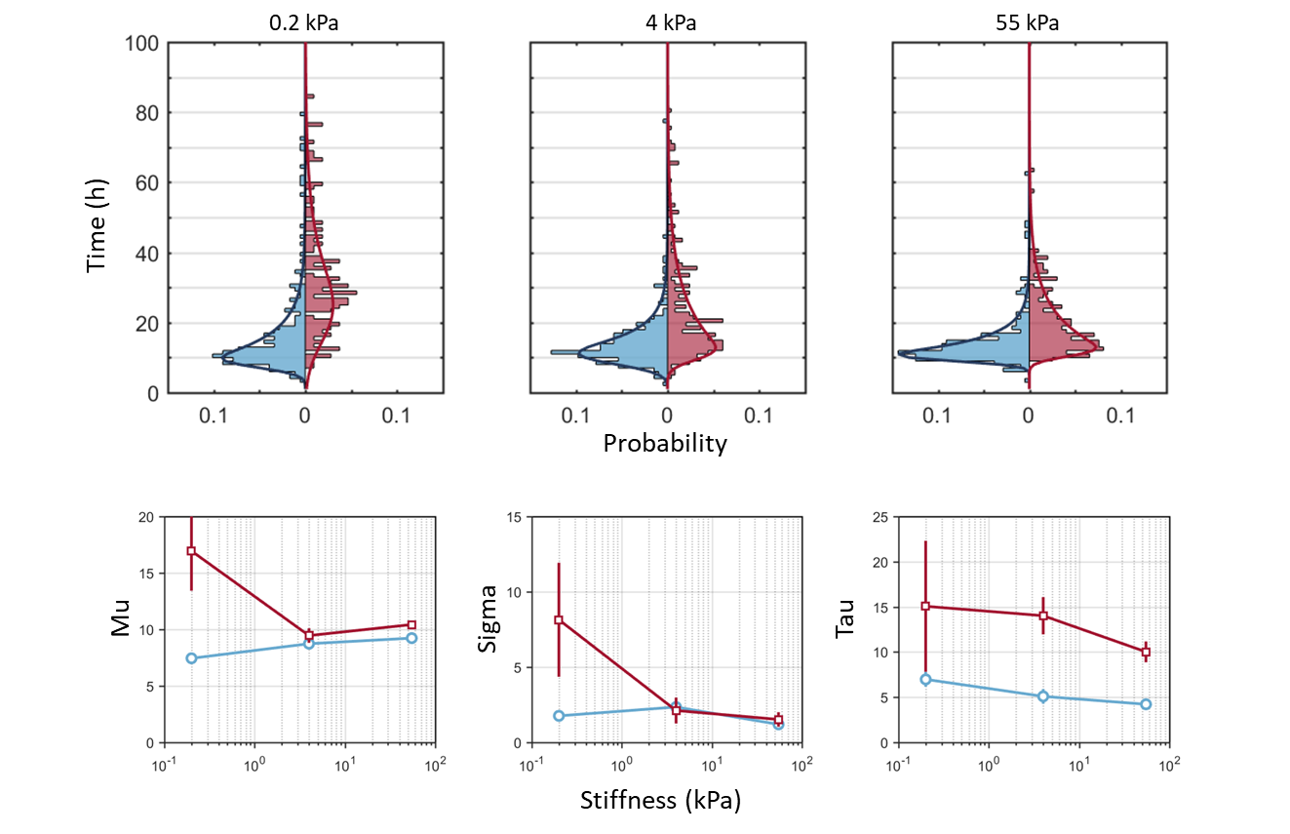
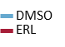
A.
B.

Supplemental

Signal transduction network
Our goal is to connect cell surface signaling to cell fate decision. The cell surface contains a multitude of proteins that allow the cell to sense its surroundings. The microenvironment has been shown to have a significant effect, both in our studies and prior work, on cell behavior and tumor treatment response. However, modeling the full transduction network is outside the scope of this project and the capability of our stochastic technique. Understanding the signal transduction network and its feedback has its own set of challenges. In the current study, we have chosen to map RTK expression and signaling directly to AKT and ERK activation levels. However, we offer a brief review of the pathway from receptor to AKT and ERK activation. Regardless of mechanism, both integrins and RTKs signal through AKT and ERK. These signaling axes are major signaling nodes within the cell. The idea is part of an emerging theory of so-called “bow-tie” signaling that represents a characteristic feature of robust, evolvable systems [62]. The amount of plasticity afforded to the signaling network from RTKs and integrins is considerable.

Receptor tyrosine kinases (RTKs)
RTKs represent an important class of proteins within oncogene-addicted cancers. The receptor family is often overexpressed or possesses activating mutations, leading to disease progression. This cancer subclass derives its name from the apparent reliance on oncogene signaling for continued survival. In this study, we focus on two of the receptors from the RTK family: hepatocyte growth factor receptor (HGFR or cMet) and EGFR (or ErbB1 or Her1). RTKs have similar molecular architecture with a single transmembrane helix that connects an extracellular ligand binding domain to an intracellular, conserved protein tyrosine kinase (PTK) domain [63]. Upon ligand binding, the receptor can either homo- or heterodimerize with subsequent tyrosine autophosphorylation. Both cMet and EGFR have shown the capability to signal through the same pathways, ultimately activating both AKT and ERK.
The ErbB family consists of four different members that are structurally similar. We focus on EGFR as it is often mutated in NSCLC. The cytoplasmic domain has at minimum 20 tyrosine residues capable of phosphorylation, seven of which are autophosphorylation sites [64], [65]. Our model cell line, PC9, harbors an exon-19 deletion within the PTK domain, making EGFR constitutively active. This particular mutation occurs in approximately half of all EGFR-mutated lung tumors [66].
Aberrant cMet expression and activation has been correlated with poor prognosis in cancer. Furthermore, we have shown that elevated cMet expression correlates with the erlotinib-resistant phenotype characterized by an increased drug-induced proliferation (DIP) rate. It has also been shown that MET amplification leads to gefitinib resistance by heterodimerizing and activating ErbB3, a member of the ErbB family mentioned previously [67].
Upon activation, cMet recruits and activates many downstream signaling molecules at the plasma membrane. A key adaptor is growth factor receptor-bound protein 2 (GRB2), which facilitates the binding of the nucleotide exchange factor Son of Sevenless (SOS) [68]. SOS functions as a guanine nucleotide exchange factor that acts on the proto-oncogene c-rat sarcoma viral oncogene homolog (Ras) family of small GTPases. Ras operates by binding rapidly accelerated fibrosarcoma (Raf) kinases and translocating Raf to the cell membrane for activation. The activation of Raf represents the first step of the integral MAPK cellular signaling module. The module is composed of MAPK kinase kinase (MAP3K, Raf), MAPK kinase (MEK, MKK), and ERK.
The AKT signaling cascade is also initiated by RTK activation. Upon RTK activation, the phosphoinositide 3-kinase (PI3K) family can bind to the intracellular domain of the RTK, resulting in the conversion of phosphatidylinositol (4,5)-bisphosphate (PIP2) to phosphatidylinositol (3,4,5)-trisphosphate (PIP3) at the plasma membrane. PIP3 then recruits AKT to the membrane, where it is activated.
The signaling cascade between receptor and AKT and ERK contains a multitude of molecules with significant crosstalk. We highlight canonical pathways from our selected RTKs to AKT and ERK but have chosen to measure AKT and ERK activation directly for our model. We pay particular attention to AKT and ERK signaling, as they represent a point of convergence within the transduction pathway.

Integrins
Integrins are class of receptors connecting the ECM with the cellular cytoskeleton. They provide the cell with important mechanical cues controlling a wide range of cellular responses. We focus on their role in cell cycle regulation. Cellular proliferation is highly altered in cancer. Knowledge of how integrin signaling alters the proliferative state of a cell population will help develop new treatment strategies.
Integrins are transmembrane, heterodimeric receptors. Mammals possess 18 α and 8 β subunits that can form 24 heterodimers. There are several mechanisms as to how integrins promote cellular proliferation. Integrins signal through the same canonical pathways as RTKs, both the PI3K/AKT and Ras/Raf/MEK/ERK axes. Integrins are also capable of regulating RTK expression at the transcriptional level [69]. Within the cell, integrins facilitate the formation of cell adhesion complexes consisting of numerous adaptor proteins (e.g. paxillin, vinculin, talin). Focal adhesion kinase (FAK) is an additional protein recruited to the focal adhesion complex. We use FAK phosphorylation as a means of measuring cellular signaling response to stiffness. Once activated, FAK can engage PI3K, thus activating the AKT signaling pathway. Additionally, FAK is capable of signaling through the ERK axis by forming a complex with GRB2 and activating the Ras family of GTPases [70].

Mitosis
Activated AKT and ERK are responsible for initiating the cell cycle through the activation of several transcription factors. The scheme and approach for our mitosis module is inspired by the Goldbeter skeleton model, which itself is based off a larger, more comprehensive model that Goldbeter and colleagues have developed [55], [56]. The objective of the model is to reduce the number of variables and parameters necessary to capture the complex phenomena of cell division. Making the model simpler allows for quicker simulation and the ability to search through parameter space. Also, it allows us to begin interpreting the minimal signaling circuitry necessary to capture complex cellular phenomena. The model is constructed around the Cdks that regulate the progression of the mammalian cell cycle through the consecutive phases of mitosis. The cell cycle can be divided into four phases marked by the sequential activation of specific cyclins and their associated kinases.

G1 phase
In the first phase, ERK directly phosphorylates cMyc. The myc family of genes are transcription factors that result in the expression of genes that drive the cell cycle (down regulation of p21 and upregulation of cyclins). They also play an important role in other vital cell processes such as apoptosis, differentiation, and growth. In addition, ERK promotes the formation AP1, which in turn, stimulates the production of cyclin D. In our model, both of these steps are modeled directly with no intermediates. Cyclin D forms an inactive complex with p21/p27, inhibiting the cell cycle. p21/p27 is negatively regulated by FAK activity.
Additionally, activated AKT induces both Myc and cyclin D activation through several mechanisms. First, AKT phosphorylates glycogen synthase kinase 3 (GSK3) preventing the degradation of cyclin D [71]. AKT also stimulates mTOR signaling, increasing the translation of cyclin D by activating ribosomal protein S6K [72]. The transcription activity of Myc is promoted by AKT-mediated degradation of Mad1. Mad1 is an inhibitor of Myc [73].
Central to the G1/S transition is a bistable switch comprised of Rb and the transcription factor E2F. E2F is another set of transcription factors responsible for both activating and suppressing transcription. In this work, we focus on their role as activators. E2F upregulates the synthesis of cyclins D, E, and A, helping to drive the transition through the cell cycle. Conversely, hypophosphorylated Rb inhibits entry into the cell cycle by binding to E2F, thereby preventing the expression of necessary cell cycle-promoting factors. Rb exists in three forms: hypophosphorylated, monophosphorylated, and hyperphosphorylated states. Each of these serve a specific function within the cell. Our simple model only takes into account two forms of Rb: the non- and phosphorylated (combined mono- and hyper-) states. In our model, cyclin D/Cdk4-6 complex phosphorylates Rb, inhibiting it from binding to E2F. Cyclin E/Cdk2 complex further phosphorylates and inactivates Rb. Biologically, the cyclin D complex is responsible for monophosphorylating Rb and the cyclin E complex hyperphosphorlates Rb, progressing the cell cycle. We model this by increasing the Rb phosphorylation rate from the cyclin E complex in comparison to the cyclin D complex.

S phase
Once cyclin E levels – stimulated by E2F – reach a threshold, the cell moves from G1 into S. Cyclin E/Cdk2 can form an inactive complex with p21/p27. A positive feedback loop controls further activation of the cyclin E/Cdk2 complex through Cdc25. We do not explicitly include Cdc25 in this model, but the effect of its positive feedback is included via self-activation of cyclin E. Through S-phase kinase-associated protein 2 (Skp2), cyclin E phosphorylates p21/p27, marking it for degradation. Skp2 also degrades cyclin E, helping the cell cycle to progress. Inactivation of cyclin E can occur through Wee1 kinase. In our model, the cyclin E complex is inactivated by the emergence of the cyclin A/Cdk2 complex.

G2 phase
The S/G2 transition occurs with the synthesis of active cyclin A/Cdk2 complex, driven by E2F. Cyclin A supports the transition through S phase by both inactivating E2F and inhibiting cadherin-1 (CDH1). In turn, CDH1 degrades Skp2, which stimulates the degradation of cyclin E. The reduction in cyclin E activity facilitates the proper progression through S phase. Further control is exhibited through p21/p27 binding, sequestering cyclin A out of the available pool. It has been shown that Wee1 also inactivates cyclin A, similar to cyclin E. We do not include this step. Instead, cyclin A is ultimately inactivated by Cdc20, the final component of our mitotic model.

M phase
Cyclin A triggers the activation of the cyclin B/Cdk1 complex, signaling the progression of the cell cycle into M phase. In the full model, cyclin B is degraded by CDH1, with constant synthesis of cyclin B. When CDH1 is inhibited by cyclin A, cyclin B levels can then increase unhindered. In the simple model, cyclin A activates cyclin B directly. Subsequently, cyclin B activates Cdc20, which, in turn, negatively regulates cyclin B and cyclin A. Negative feedback pathways acting through cyclin B and Cdc20 down regulate cyclin A and help set the proper progression through division.

Apoptosis
We have included an intrinsic apoptosis module to account for cell death in our model by adapting a portion of the Tyson model for apoptosis [74]. ERK, in addition to AKT through forkhead box O3 (FOXO3), negatively regulates BCL-2-like protein 11 (BH3 or BIM). When AKT and ERK are low, BH3 levels increase. B-cell lymphoma 2 (BCL2) initially binds to and removes active BH3 from the activating pool. However, if AKT and ERK remain low, BH3 levels continue to rise, leading to the activation of BCL2-like protein 4 (BAX). Within the cell, BH3 instigates a conformational change within BAX, allowing it to insert into the mitochondrial membrane. BAX oligomerizes with itself to form a pore, allowing the release of cytochrome c and apoptotic factors. Once this occurs, the apoptosis decision within the cell is final. Additionally, BAX negatively regulates BCL2, preventing BCL2 from binding and inhibiting BAX. The relationship allows for a bistable response to low AKT and ERK inputs. In the model, BAX is inactivated at a basal level to prevent accumulation and premature cell death.

